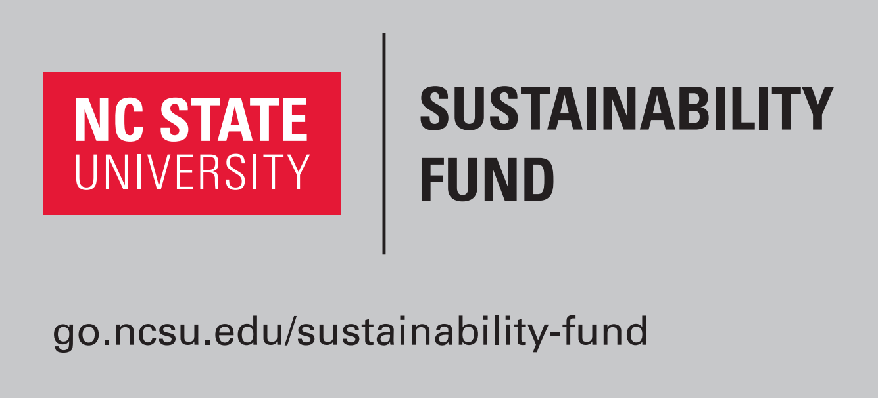

The Sustainability Fund Project Application

Background and Context:
The NC State University Sustainability Fund Advisory Board announces the fourth annual request for proposals to advance sustainability on campus. This RFP is for projects that have high immediate impact or for longer-term projects that have significant potential for high impact. Projects can focus on education, outreach, infrastructure or any other component of campus sustainability. Examples include workshop development and sponsorship, symposium development, projects aimed at some aspect of sustainability, pilot projects to demonstrate potential for successful use of longer-term funding, large-scale infrastructure improvements, or other creative uses of these student-fee derived funds. Faculty or staff directed projects are appropriate if accompanied by a statement indicating how students will participate in the project or how students will benefit from project completion. Students are encouraged (but not required) to develop projects in conjunction with a faculty mentor or advisor. Pursuit of matching funds from other public or private sources is recommended. Letters of support from advisors and partners are strongly encouraged (letters of support from additional funding partners are required).

Proposals are due by 11:59 pm on February 19, 2017. Funding decisions will be made by April 20, 2017. Projects begin July 1, 2017. Mid-year reports are Due December 1, 2017 and end of project reports are due by June 15, 2018.

All materials must be submitted electronically. Please complete the following information:

Application Date:
Project Title:
Total Requested Amount:

*Total available funding is $140,000 for all projects in the current funding cycle. Individual project funding amounts will vary depending on number and scope of projects funded. In exceptional cases, funding renewal will be considered with re-application.

Applicant Information
Name of Primary Contact:
Please mark your status with an “X”: ☐ Student ☐ Staff ☐Faculty
Campus Affiliation (Name of Organization, Department, or Office):
Email Address: Cell and/or Work Phone:
Campus Mailing Address:

If you are a student, please provide the following information:
☐ This project is solely my own OR
☐ This project is proposed on behalf of (student org., campus dept., etc.):

Name of Faculty or Staff Project Advisor (if applicable):
Faculty or Staff Project Advisor Contact Information:
Email Address:
Campus Address:
Phone Number-Day-time/Work: Cell Phone:

Please organize your proposal into the following 8 sections and answer the prompting questions where applicable. Total proposal length should not exceed 6 pages (1 inch margins, 11 point font). Additional documentation (e.g., letters of support, maps, drawings, etc.) should be submitted as appendices and clearly labeled to aid committee review (does not count toward 6 page limit).

Please include a bulleted list of any attachments (including file names) here:

Please email your application materials to dasa-sfab-chair@ncsu.edu. Include both a .docx and .pdf file of your application. Please include “Sustainability Fund Application” in the subject line. You will receive electronic confirmation that your materials have been received.

Please review the application materials and online content carefully. If you still have questions, please email the Fund Advisory Board Chair at dasa-sfab-chair@ncsu.edu with your specific question, or feel free to call 919-606-9146 with any questions.

1) Project Description
Provide a 1 - 2 page summary of your project with enough detail that reviewers will clearly understand your project goal(s), your approach, and how you expect your project to impact some aspect of sustainability on campus.

2) Anticipated Outcomes/Impact
What outcomes do you anticipate? How will your project improve student life, infrastructure, education, outreach, operations, or other aspects of sustainability? How will you educate the campus community about your project?

3) Project Benchmarking & Innovation
Have similar projects been implemented on other campuses? Why should this be done at NC State?

4) Metrics for Assessment
How will you measure and evaluate your project’s success?

5) Cost Savings
Will the project result in cost savings? ▢Yes ▢ No
If yes, what is the payback period?

6) Broader Vision
What potential does this project have for long term benefits to the campus community? Is there potential for your project to be scaled for broader community application? As you are developing this project, how do you plan on sustaining leadership of the project into the future?

7) Project Milestone
Indicate your major project milestones including dates (month/year) of expected completion.

8) Project Budget & Justification
What is the total project budget? What is your plan for sustained funding? Please include a detailed budget that includes each of the following categories: personnel, supplies and materials, travel, and other.

9) How did you hear about the Sustainability Fund’s Request For Proposals and what recommendations do you have for improving the process?

If project receives funding, applicants will be expected to report project status to the Sustainability Fund Advisory Board and notify the Board of any major changes in scope. The Board reserves the right to discontinue the funding of any project if the project is determined to be unattainable in the time frame or deviating too far from its original funding purpose. It is the duty of funded projects to acknowledge funding from the NC State Sustainability Fund.

