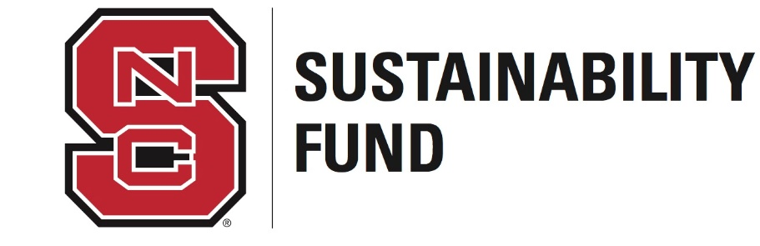

Sustainability Fund Advisory Board
Student Application Packet

The Sustainability Fund Advisory Board manages the funds raised through the student sustainability fee that was established in 2013. This fee is expected to raise approximately $125,000 in 2016-2017 from a $4.50 per student per year fee. These funds are then made available to the NC State community through the Board’s competitive grant process for sustainability-related projects, education, and other resources that enhance campus and student learning in relation to sustainability. The Board meets approximately once a month and is responsible for reviewing applications, marketing the Request for Proposals, and general oversight of funded projects. Student Board members are required to serve at least one year on the Board. There are four undergraduate student positions and one graduate student position, and only one of these undergraduate positions is available for next year.

PERSONAL INFORMATION

1. Full Name:
2. I certify that I am a FULL TIME student. (Yes / No)
3. Mobile Phone:
4. Email Address:
5. Current College(s):
6. Current Major(s):
7. Minors (If Applicable):
8. Projected Graduation Date (Fall/Spring):

Please answer the following questions below. You may write your responses directly into this document. Each response should be one paragraph.

1. Explain your interest in sustainability.

2. Have you been involved in any sustainability-related projects, activities, organizations, etc.? If so, please provide details.

3. What other organizations are you a part of and what positions do you hold?

4. Why do you want to be a member of the Board? What experience would you provide the Board?

Please attach résumé (with GPA listed) to your application.
Return this application by April 21st at 5:00 pm via email to dasa-sfab-chair@ncsu.edu.

