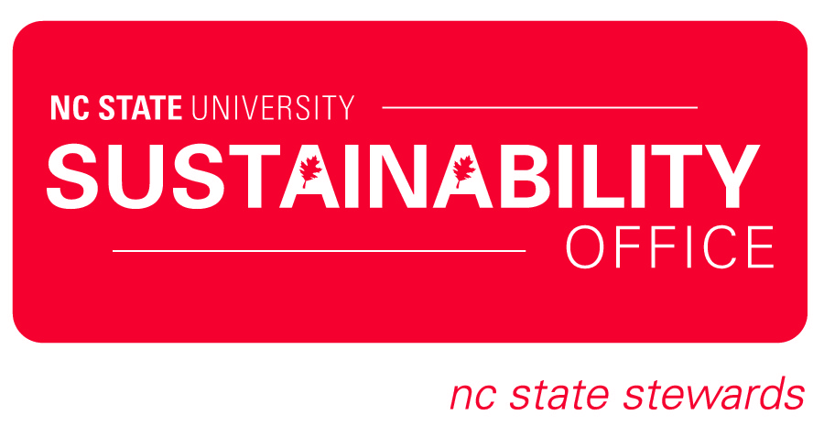
Application Packet

PERSONAL INFORMATION

1. Full Name:
2. I certify that I am a FULL TIME student. (Yes / No)
3. Mobile Phone:
4. Email Address:
5. Current College:
6. Current Major:
7. Minors (If Applicable):
8. Projected Graduation Date (Fall/Spring):
9. Will you be living on campus Fall 2013-Spring 2014?
10. If yes, where?
11. Where is your hometown?

Please answer the following questions below. You may write your responses directly into this document.

1. What would you change on campus if you could to make it more sustainable?

2. List three adjectives to describe yourself:

SHORT ANSWER QUESTIONS

1. The NC State Stewards program’s mission is “to fulfill the vision of a more sustainable campus, community and world, individuals must adopt more sustainable practices. As the university’s student sustainability ambassadors, NC State Stewards are trained to promote sustainable actions on campus and among their peers so that environmental, social and economic responsibility is cultivated at NC State and beyond.” Why do you think this is important to our campus? (250 words maximum)

2. Why do you care about sustainability and what does it mean to you?

3. What will you contribute to the NC State Steward program and what do you hope to gain from this experience? (250 words maximum)

4. NC State Stewards are educators, leaders, activists and role models on our campus.
Please describe your experience with at least one of these roles. (200 words maximum)

Return this application by March 7 via email to ncstatestewards@ncsu.edu.

