**C**ampus   
**E**nvironmental   
**S**ustainability   
**T**eam

**Agenda**January 18, 2:00 – 3:00 pm124 Administrative Building III

2:00 – 2:05 Welcome – Bill Winner

2: 05 – 2:25 SuSTATEable*\**

* Topic: PackLink, a pilot for matching campus sustainability project needs with resources – Lindsay Batchelor and Liz Bowen, University Sustainability Office

(Example of progress on the following SSP strategies: Academics and Research 4 and 7 )

2:25 – 2:35 Earthwise Awards update – Walt Robinson, Earthwise co-chair

2:35 – 2:55 Tactical plan and implementation updates – Working Group chairs

* Metric status (due on Feb. 27)

2:55 - 3:00 Group photo for CEST web site

**Status Updates**

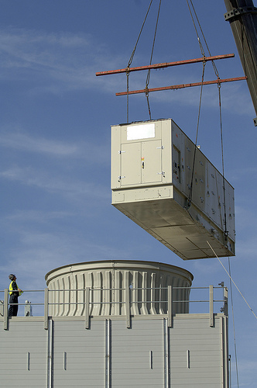

* Walt Robinson and Jennifer Bell have enthusiastically agreed to co-chair the revamp of the Earthwise Awards
* The Sustainability Office and Student Government are starting discussions about the possibility of having a student sustainability fee in place for the 2013/14 academic year
* By March, NC State will submit sustainability data to the AASHE Sustainability Tracking, Assessment, and Rating System (STARS) as the main avenue for publically reporting sustainability data
* The sustainability policy group is almost formed – we are waiting on additional faculty and student representation before setting the kickoff meeting
* Over winter break 2 combustion turbines and 2 heat recovery steam generators were crane lifted into the Cates plant for the combined heat and power project.

*SuSTATEable will be a regular segment on the CEST agenda to learn about sustainability progress connected to the Sustainability Strategic Plan.

**2012 CEST Meeting Schedule**  
Every ~5-6 weeks

|  |  |  |
| --- | --- | --- |
| **Date** | **Meeting Type** | **Agenda** |
| Feb 27 | CEST meeting | Status updates  Metrics finalized  Speaker: TBD |
| March 26 | CEST meeting | Status updates  Start FY 12/13 planning of 1 year tactics |
| Apr 9 | CEST meeting/Earthwise | Earthwise awards &celebration |
| Apr 20 | NCSU Earth Day |  |
| May 21 | CEST meeting | Status updates  Continue FY 12/13 1 year tactical planning  Speaker: TBD |
| June 18 | CEST meeting | Complete FY 12/13 1 year tactical planning  Begin gathering updates/metrics for Annual Sustainability Report  Speaker: TBD |
| Aug 27 | CEST meeting | Continue gathering updates/metrics for Annual Sustainability Report  Speaker: TBD |
| Sep 10 | Metrics/updates for Annual Sustainability Report due to Sustainability Office | Annual Sustainability Report release Campus Sustainability Day, late October |